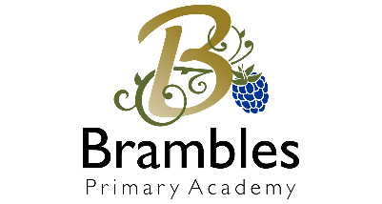**Keeping Children Safe at Brambles Primary Academy**

Our children’s safety is our first priority

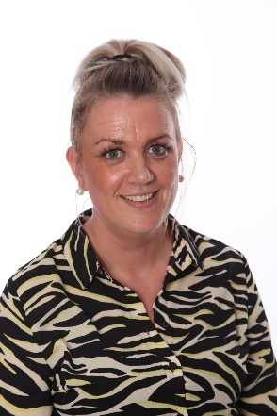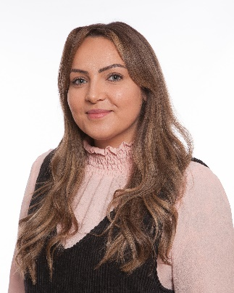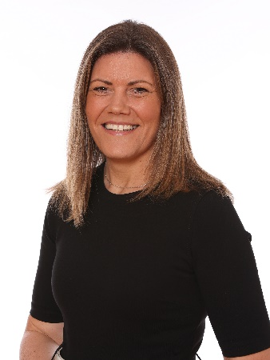If you have any worries or concerns whilst you are in our Academy, here are some of our team who will be able to help you:

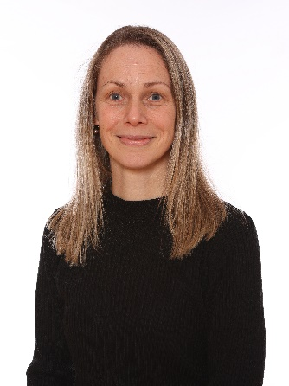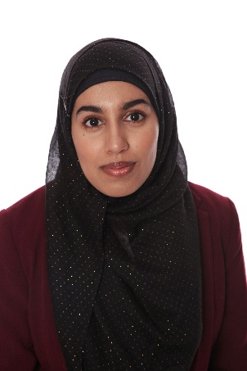

**Mrs Charlotte Bowker**

Adult and Children’s Mental Health & Wellbeing First Aider

**Miss Becky Machon**

SENDCo

First Aider

**Mrs Hayley Gec**

Phase Leader

Deputy Safeguarding Lead

First Aider

**Mrs Sallie Dodd**

Principal

Designated Safeguarding Lead

First Aider

**Mrs Zakia Akhtar**

Office Manager

First Aider